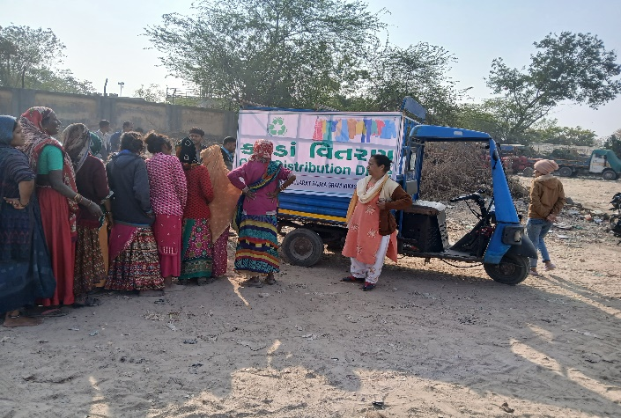
Circular Textile Reuse and Recycling Initiative
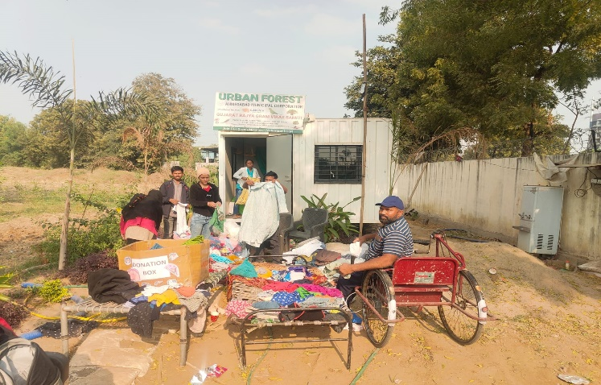

Subject: Technical Proposal for "Neki Ki Diwar" – Circular Textile Reuse and Recycling Initiative

Gujarat Rajya Gram Vikas Samiti (GRGVS) is pleased to submit this Technical Proposal for implementation of the "Neki Ki Diwar" initiative.

Established in 1988, GRGVS has over three decades of experience in community development, women empowerment, livelihood promotion, environmental sustainability, education, health, and CSR project implementation across Gujarat.

We are confident that our existing infrastructure, warehouse facility, tailoring support systems, volunteer network, women SHGs, and project management capabilities position us as a suitable implementation partner for this initiative.

EXECUTIVE SUMMARY

"Neki Ki Diwar" presents a transformative opportunity to convert textile waste into a powerful social and environmental resource — weaving together community care, sustainable consumption, and women's livelihood in one cohesive model.

GRGVS proposes a structured, end-to-end circular textile ecosystem involving:

Collection | Sorting | Washing | Refurbishment | Packaging | Redistribution | Recycling

Key outcomes of this initiative include:
- Reducing textile waste and landfill burden
- Promoting sustainable and circular consumption
- Generating meaningful livelihood for 50+ women through SHGs
- Improving access to quality, affordable clothing for vulnerable communities
- Building an integrated environmental and social impact model

50+  Women Engaged via SHGs | 12 Months  Project Duration | 6  Operational Phases
6+  Collection Channels | 5  Distribution Modes | 37+  Years of GRGVS Experience

UNDERSTANDING THE PROJECT

India generates millions of tonnes of textile waste annually. Ahmedabad, as one of the country's major textile hubs, produces significant quantities of both post-consumer and pre-consumer textile waste that ends up in landfills, burdening the city's environment.

The "Neki Ki Diwar" initiative presents a community-driven, circular economy solution to this challenge. The proposed project seeks to:

- Divert usable garments from landfills through structured collection
- Promote reuse and extend the life cycle of donated garments
- Support a circular economy through sorting, refurbishment and recycling
- Create women-centric livelihood opportunities through SHG engagement
- Improve access to affordable clothing for vulnerable and underserved communities
- Build sustained community awareness around textile sustainability
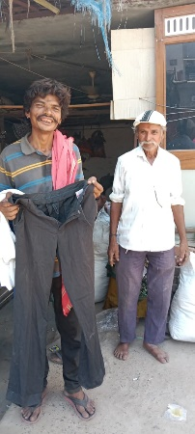
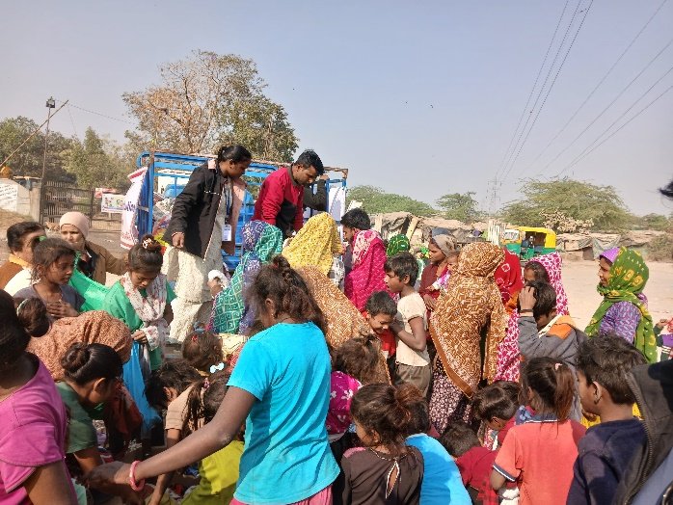

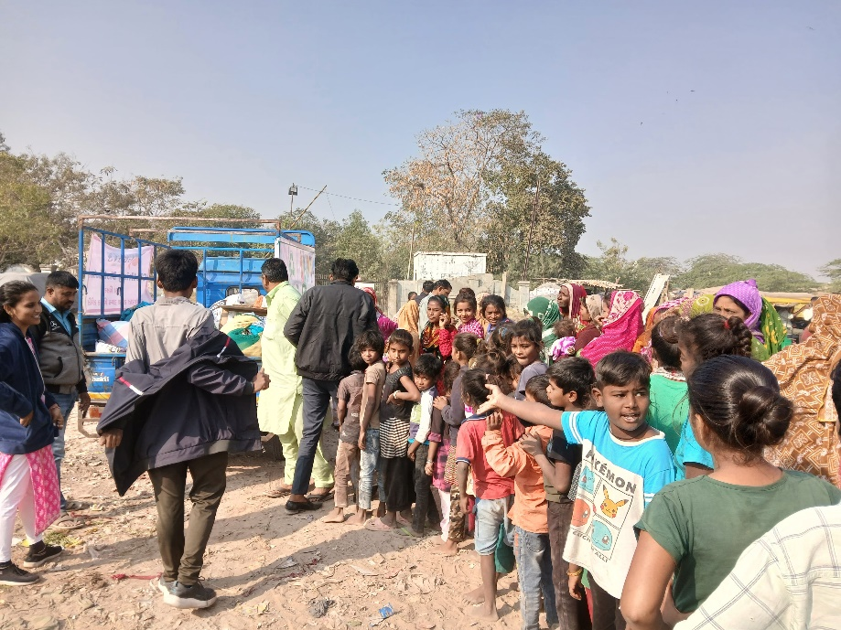
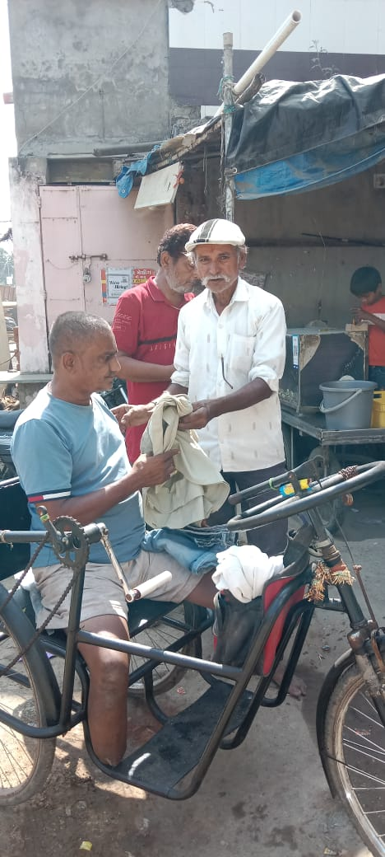

GRGVS Urban Forest Site — 'Neki Ki Diwar' Donation Collection Activity

PROJECT OBJECTIVES

1 | Establish a structured textile collection ecosystem across Ahmedabad.
2 | Divert usable garments from landfills through community participation.
3 | Promote garment reuse and advance circular economy principles.
4 | Create dignified livelihood opportunities for women through SHG engagement.
5 | Increase public awareness regarding textile sustainability and responsible consumption.
6 | Develop a scalable, replicable, and financially sustainable model.

IMPLEMENTATION METHODOLOGY

Phase | Activity | Details
1 | COLLECTION | Sources: GMDC Offices, Residential Societies, Schools, Colleges, Corporates, Community Drives. Methods: Collection Boxes, Mobile Collection Vehicle, Awareness Campaigns
2 | SORTING | Garments categorized by: Gender (Men / Women / Children), Type (Winter Wear, School Uniforms, Ethnic, Western), and Condition (Reusable / Refurbish / Recycle)
3 | REFURBISHMENT | Process: Sorting → Washing → Drying → Repair/Stitching → Ironing → Quality Check → Approval for Distribution
4 | PACKAGING | Each garment tagged with: Category, Size, Gender, Unique ID, and Minimal Sale Price for traceability
5 | DISTRIBUTION | Channels: Mobile Retail Unit, Community Sales Camps, Special Events, NGO Referrals, Direct Outreach
6 | RECYCLING | Non-usable garments upcycled into: Cleaning Cloths, Bags, Mats, Craft Products, reducing landfill to near-zero

OPERATIONAL STRATEGY

Warehouse Facility
- Dedicated Storage Area for incoming donations
- Sorting Area with category-wise racks and bins
- Washing & Drying Area with adequate equipment
- Repair & Stitching Area staffed by trained SHG women
- Packing & Dispatch Area for final quality-approved garments

Inventory Management
- Stock Register with daily entry and exit records
- Unique Tagging System per garment for traceability
- Digital Records using MIS tools for real-time tracking
- Monthly Inventory Reconciliation and reporting to GMDC-GVT

Women Livelihood & SHG Engagement Model

GRGVS proposes engagement of 50+ women through Self Help Groups (SHGs) for the following roles:

Role | Skill Developed | Benefit
Sorting & Grading | Quality Assessment | Income + Skill
Stitching & Repairs | Tailoring & Upcycling | Income + Entrepreneurship
Packaging & Tagging | Logistics Management | Income + Self-Reliance
Inventory Management | Record Keeping / MIS | Income + Digital Literacy
Community Mobilization | Communication & Outreach | Leadership Development

WORK PLAN AND TIMELINE

Period | Activity
Month 1–2 | Project Setup: MoU Signing, Warehouse Preparation, Staff Hiring, Awareness Campaign Launch
Month 3–4 | Collection Drives Launch: Box Installation, Mobile Vehicle Operations, Corporate & Society Outreach
Month 5–6 | Sorting, Washing & Refurbishment: Full Operations, SHG Onboarding, Quality Systems Activation
Month 7–9 | Distribution Begins: Mobile Retail Unit, Community Sales Camps, NGO Referral Network Activation
Month 10–12 | Recycling & Expansion: Upcycled Product Development, Scale-Up, Impact Documentation & Reporting

MONITORING & EVALUATION FRAMEWORK

Key Performance Indicators

Key Performance Indicator | Annual Target
Number of garments collected | 5,000+
Number of garments refurbished | 3,500+
Number of garments distributed | 3,000+
Number of garments recycled/upcycled | 1,500+
Women engaged through SHGs | 50+
Beneficiary households reached | 2,000+
Monthly collection drives conducted | 2 per month

Monitoring Tools
- Collection Register — daily garment intake log
- Inventory Register — sorting category-wise tracking
- Beneficiary Records — distribution documentation
- Monthly Progress Reports submitted to GMDC-GVT
- Photographic and Video Documentation of all activities

EXPECTED OUTCOMES

5,000+  Textile Waste Reduced | 3,000+  Garments Redistributed | 50+  Women Empowered
2,000+  Families Benefited | 1,500+  Upcycled Products Created | 10+  Collection Points Established

Beyond numbers, this initiative will build a replicable community-owned model of circular textile economy — one that can be scaled across Gujarat and nationally.

CONCLUSION

GRGVS is fully committed to supporting GMDC-GVT in establishing a sustainable, scalable, and socially impactful circular textile reuse and recycling ecosystem through the "Neki Ki Diwar" initiative.

